Sir Syed University of Engineering and Technology

Software Engineering Department

Operating System (SWE-204L)

Software Requirement Specification

Topic: Phone Directory

Semester: 4th

Section: E



Prepared by:

Karishma Zaheer (2020-SE-219)

Aleena Waqar (2020-SE-204)

Syeda Maira Hussain (2020-SE-210)

Sidra Khan (2020-SE-198)

Table of Content:

Table of Content……………………………………………………………………………….2

1. Introduction……………………………………………………………………………3

1.2. Purpose……………………………………………………………………………3

1.3. Intended Audience and Reading Suggestions…………………………………….3

1.4. Product Scope…………………………………………………………………….3

1. Overall Description……………………………………………………………………3
   1. Product Perspective……………………………………………………………….3
   2. Product Function………………………………………………………………….3
   3. User Classes and Characteristics………………………………………………….3
   4. Operating Environment…………………………………………………………...4
2. Snapshots………………………………………………………………………………5
   1. Text editor………………………………………………………………………...5
   2. Terminal…………………………………………………………………………..6
   3. Output ……………………………………………………………………………7

# Introduction

## Purpose

Our project “PHONE DIRECTORY” has all the basic functions in which a contact can be ADDED, SEARCHED, UPDATED, DELETED, VIEW PHONE DIRECTORY or QUIT.

We’ve used SHELL SCRIPTING to make our project. SHELL SCRIPTING is a text file that contains a sequence of commands for a UNIX-based operating system. It combines a sequence of commands that would otherwise have to be typed into the keyboard one at a time, into a single script. The PHONE DIRECTORY helps in to maintain the contacts in one place with such functionalities.

## Intended Audience and Reading Suggestions

This document is intended for all kind of readers since the PHONE DIRECTORY is the need for each person. This would help developers in some other way that how can they develop good and advanced directories, project managers in other way to how the new ideas can be given for a better progressive directories and other people in some other way.

## Product Scope

This Project has a lot of scope since nobody can memorize things on their own. Everyone needs a record keeper to maintain the records similarly to keep the contacts saved in one place it is necessary to have a PHONE DIRECTORY. So that people won’t get bothered to save the numbers somewhere else.

1. Overall Description
   1. Product Perspective:

This product is phone directory which basically stores the information of the contact of people i.e. the name and number. This makes work easier as it is impossible to remember all he numbers so a phone directory helps save contact so you can contact easily.

* 1. Product Functions:

The functionalities that the product performs is first of all making a new contact’s name and number and saving it in the directory. Then we can delete the contact we want to. We can view all the contacts of phone directory that are available there. We can search the directory of the desired contact that we want.

* 1. User Classes and Characteristics:

In this the classes since the project is based on shell scripting, we have used the shell scripting language that is the bin bash command, echo which basically prints the statement, read which executes the statement, we used the while loop for executing the line of command. If loop for execution as well.

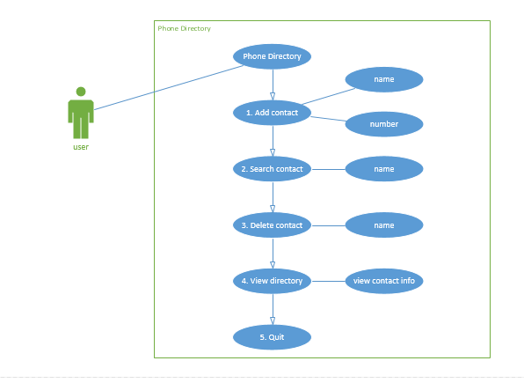

* 1. Operating Environment:

The environment it works on is Linux platform terminal, ubuntu (64-bit) and the language is shell scripting.

1. Snapshots
   1. Text Editor

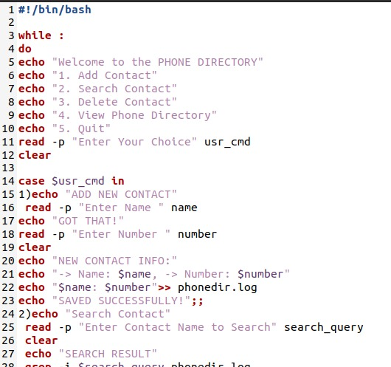

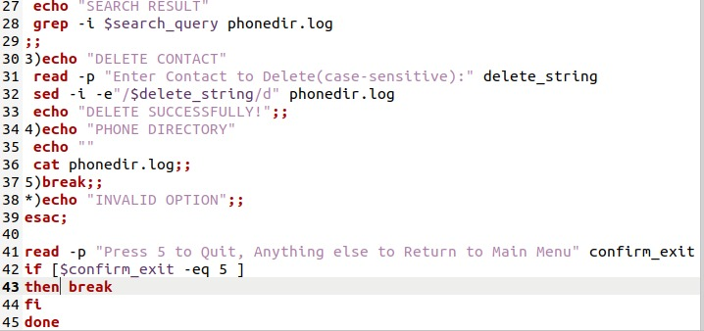

* 1. Terminal

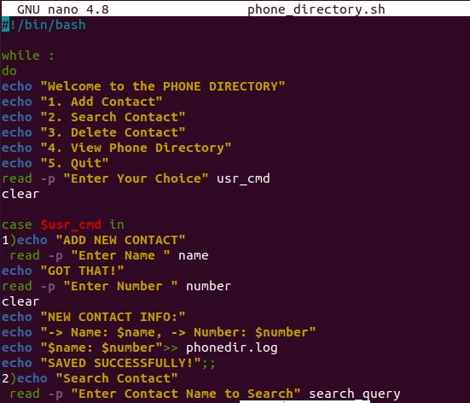

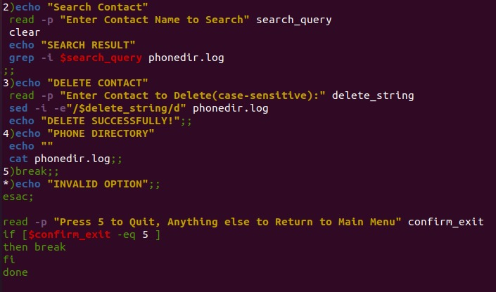

* 1. Output

